Machine Learning-Based Graduate Admission Prediction Framework

ABSTRACT
Graduate admission prediction is an important application of machine learning that can assist students and educational institutions in estimating admission opportunities based on historical admission data. This paper presents a Machine Learning-Based Graduate Admission Prediction Framework designed to analyze admission-related data and predict the admission percentage of prospective applicants. The proposed framework processes a dataset containing more than 8,000 records and performs extensive data analysis and visualization to understand admission patterns across specialization, gender, region, university ratings, and admission percentages. The preprocessing stage identifies missing values, applies data processing and normalization, and divides the dataset into 80% training and 20% testing subsets. Multiple machine learning and deep learning algorithms, including CNN2D, Support Vector Machine, Decision Tree, Random Forest, K-Nearest Neighbors, and Linear Regression, are implemented and evaluated. Model performance is measured using Mean Squared Error (MSE) and R² score to assess prediction accuracy and the difference between predicted and actual admission values. Among the evaluated models, the CNN2D model achieves an MSE of 0.018 and an R² score of 98.11, with its predicted admission percentages closely matching the actual test values. Comparative graphs and tabular results are used to analyze the performance of all models. The framework also supports uploading test data and generating admission percentage predictions using the trained CNN2D model. The results demonstrate the applicability of machine learning and deep learning techniques for data-driven graduate admission prediction.
KEYWORDS
Graduate Admission Prediction, Machine Learning, Deep Learning, CNN2D, Admission Percentage, Data Preprocessing, Data Normalization, Predictive Analytics, Model Comparison, Educational Data Mining.
EXISTING SYSTEM
In the existing graduate admission prediction approach, admission-related datasets are analyzed using conventional statistical methods and multiple machine learning algorithms to estimate admission percentages. The available system performs dataset loading, statistical analysis, visualization, preprocessing, normalization, and model training. It evaluates models such as SVM, Decision Tree, Random Forest, KNN, and Linear Regression using MSE and R² score. However, the approach has limitations in handling complex relationships among multiple admission attributes and does not provide the same deep feature-learning capability as a multi-layer CNN2D model. The uploaded project specifically implements CNN2D as a more complex learning model for admission prediction.
DISADVANTAGES:
- Limited Learning of Complex Patterns – Conventional machine learning models may have difficulty learning complex relationships among multiple admission attributes.
- Dependence on Manual Feature Representation – Traditional models generally rely more heavily on the quality and representation of input features rather than automatically learning complex feature relationships.
- Variation in Prediction Accuracy – Different models produce different prediction performance, with some showing larger differences between actual and predicted admission percentages.
- Higher Prediction Error in Some Models – Models with comparatively lower R² performance can produce greater prediction differences, reducing consistency in admission percentage estimation.
- Limited Model Capability for Complex Data – Conventional approaches may not fully exploit the complex patterns available in a large dataset containing more than 8,000 admission records.
PROPOSED SYSTEM
The proposed Machine Learning-Based Graduate Admission Prediction Framework uses a multi-layer CNN2D model as the primary prediction model. The system first loads and analyzes the admission dataset, performs preprocessing and normalization, and divides the data into 80% training and 20% testing sets. The CNN2D model is then trained to predict admission percentages. Its performance is evaluated using MSE and R² score and compared with SVM, Decision Tree, Random Forest, KNN, and Linear Regression. In the documented results, CNN2D achieved an MSE of 0.018 and an R² score of 98.11, while its predicted and actual admission percentages were shown to be closely aligned.
ADVANTAGES:
- Improved Prediction Performance – CNN2D achieved an R² score of 98.11 with an MSE of 0.018 in the documented experiment.
- Complex Pattern Learning – The multi-layer CNN2D architecture is designed to learn complex relationships within the processed admission data.
- Accurate Admission Estimation – The CNN2D prediction graph shows the actual and predicted admission percentages closely overlapping, indicating close agreement between the two values.
- Comprehensive Model Comparison – The framework evaluates CNN2D alongside SVM, Decision Tree, Random Forest, KNN, and Linear Regression using MSE and R², allowing their prediction performance to be compared systematically.
- Practical Prediction Support – The system allows test data to be uploaded and generates admission percentage predictions using the trained CNN2D model.
Modules Description
- Dataset Loading and Management – Loads the graduate admission dataset containing more than 8,000 records and displays the available data values for further processing and analysis.
- Dataset Analysis and Visualization – Analyzes the dataset using statistical information such as count, mean, and standard deviation, and visualizes important admission attributes and their high and low values.
- Admission Pattern Analysis – Visualizes admission patterns based on specialization, gender, region, admission percentage, and university ratings to understand variations in graduate admissions.
- Data Preprocessing and Normalization – Checks the dataset for missing values and performs data processing and normalization to prepare the input features for machine learning models. The dataset contains zero missing values in the shown analysis.
- Training and Testing Data Split – Divides the processed dataset into training and testing portions, using 80% of the data for training and 20% for testing.
- CNN2D Model Training – Implements a multi-layer CNN2D model for graduate admission percentage prediction. The model learns patterns from the processed admission data and generates predicted admission percentages.
- Machine Learning Model Training – Trains additional models, including SVM, Decision Tree, Random Forest, KNN, and Linear Regression, to predict admission percentages and provide comparative performance results.
- Model Performance Evaluation – Evaluates the trained models using Mean Squared Error (MSE) and R² score by comparing predicted values with the actual test values.
- Model Comparison – Compares the performance of CNN2D, SVM, Decision Tree, Random Forest, KNN, and Linear Regression using graphical and tabular representations of MSE and R² scores.
- Admission Percentage Prediction – Allows a test data file to be uploaded and uses the trained CNN2D model to generate the corresponding predicted admission percentage for the supplied input data.
SYSTEM ARCHITECTURE
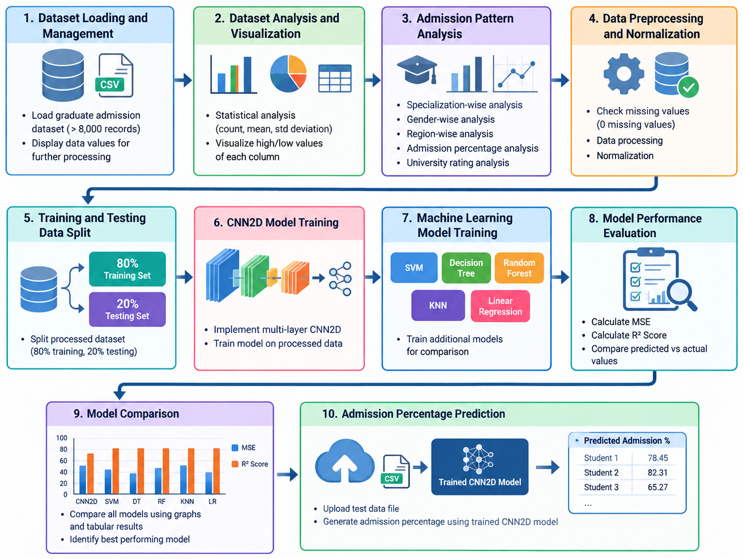
HARDWARE & SOFTWARE REQUIREMENTS:
HARDWARE REQUIRMENTS:
- Processor : intel i3(min)
- Hard Disk : 500 GB.
- Ram : 4 GB (min).
SOFTWARE REQUIRMENTS:
- Operating system : Windows 10 (min)
- Coding Language : python 3.7.9

